

Network Security and Forensics

Lab Session 7

Submitted To:- Submitted By:-

Dr. Lokesh Chauhan Sir Saloni Rangari

M.Tech. AIDS

**Assignment 1: Write a program to calculate the mod exponent of a big number.**

def mod_exponent(base, exp, mod):

result = 1

base = base % mod

while exp > 0:

if (exp % 2) == 1: # If exp is odd

result = (result * base) % mod

exp = exp >> 1 # Divide exp by 2

base = (base * base) % mod

return result

if __name__ == "__main__":

base = int(input("Enter the base: "))

exp = int(input("Enter the exponent: "))

mod = int(input("Enter the modulus: "))

print(f"{base}^{exp} mod {mod} = {mod_exponent(base, exp, mod)}")

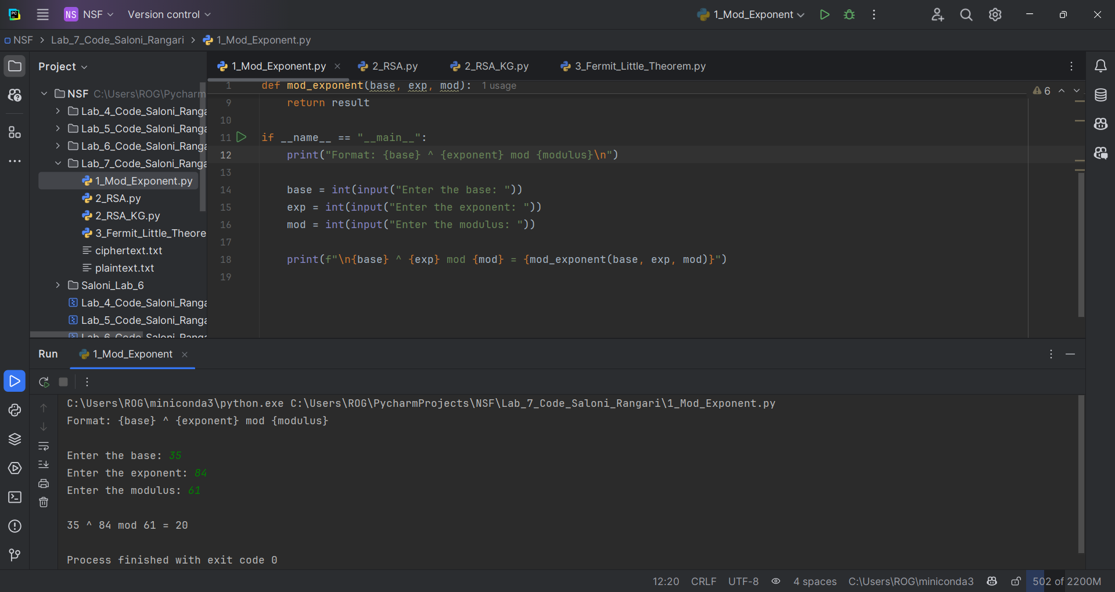**Output:**

**Assignment 2: Write a program to demonstrate RSA algorithm by taking input plaintext from a file and produce output file into ciphertext file.**

import random

from sympy import isprime

def generate_prime_candidate(length):

p = random.getrandbits(length)

return p | (1 << length - 1) | 1 # Ensure p is odd and has the correct length

def generate_prime_number(length):

p = 4

while not isprime(p):

p = generate_prime_candidate(length)

return p

def gcd(a, b):

while b:

a, b = b, a % b

return a

def multiplicative_inverse(e, phi):

d_old, d_new = 0, 1

r_old, r_new = phi, e

while r_new > 0:

quotient = r_old // r_new

d_old, d_new = d_new, d_old - quotient * d_new

r_old, r_new = r_new, r_old - quotient * r_new

if r_old > 1:

raise Exception('No modular inverse')

if d_old < 0:

d_old += phi

return d_old

def rsa_keypair(length):

p = generate_prime_number(length)

q = generate_prime_number(length)

n = p * q

phi = (p - 1) * (q - 1)

e = random.randrange(2, phi)

while gcd(e, phi) != 1:

e = random.randrange(2, phi)

d = multiplicative_inverse(e, phi)

return ((e, n), (d, n)) # Public key and private key

def encrypt(plaintext, pubkey):

e, n = pubkey

plaintext_int = int.from_bytes(plaintext.encode(), 'big')

ciphertext_int = pow(plaintext_int, e, n)

return ciphertext_int

def decrypt(ciphertext_int, privkey):

d, n = privkey

plaintext_int = pow(ciphertext_int, d, n)

plaintext_bytes = plaintext_int.to_bytes((plaintext_int.bit_length() + 7) // 8, 'big')

return plaintext_bytes.decode()

if __name__ == "__main__":

length = int(input("Enter the key length (in bits): "))

public_key, private_key = rsa_keypair(length)

with open('plaintext.txt', 'r') as file:

plaintext = file.read().strip()

ciphertext_int = encrypt(plaintext, public_key)

with open('ciphertext.txt', 'w') as file:

file.write(str(ciphertext_int))

print(f"Ciphertext: {ciphertext_int}")

decrypted_text = decrypt(ciphertext_int, private_key)

print(f"Decrypted Text: {decrypted_text}")

**Assignment 3:  Write a program to implement Fermit Little Theorem.**

def fermat_little_theorem(a, p):

if p <= 1 or not isprime(p):

raise ValueError("p must be a prime number greater than 1.")

return mod_exponent(a, p - 1, p)

if __name__ == "__main__":

a = int(input("Enter an integer a: "))

p = int(input("Enter a prime number p: "))

result = fermat_little_theorem(a, p)

print(f"{a}^{p-1} mod {p} ≡ {result} (according to Fermat's Little Theorem)")

**Output:**